Appendix A

# Indexes

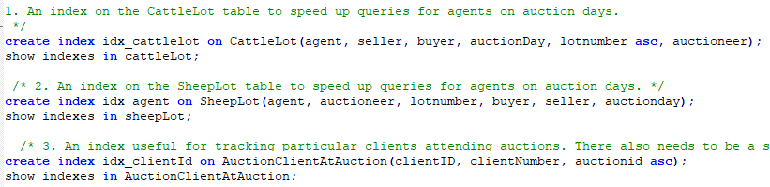

Is that what was wanted of us? It was not clear in the requirements what kind of script exactly was asked of us and we have never been taught in class about repairing/rebuilding

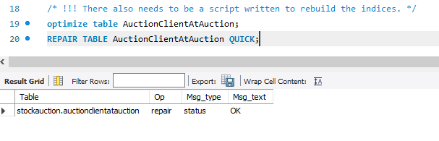

# Views

## View #1

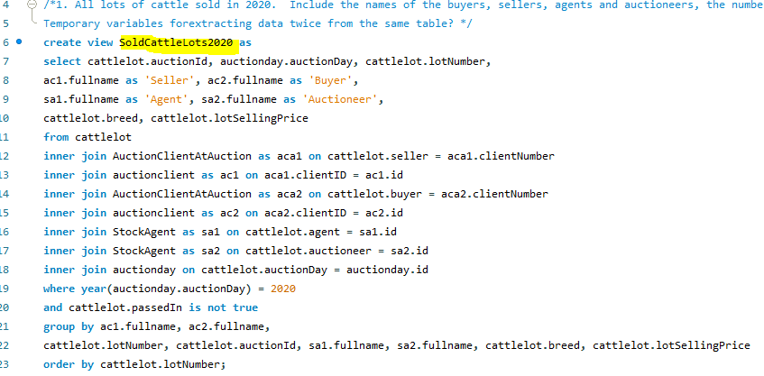

Tests:

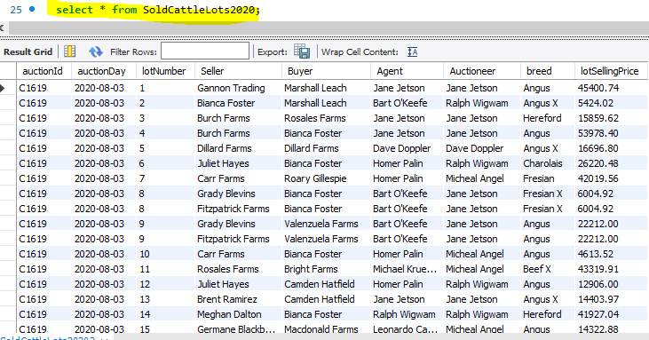Before:

After:

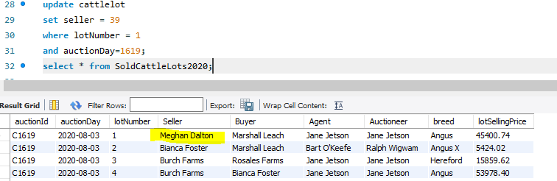

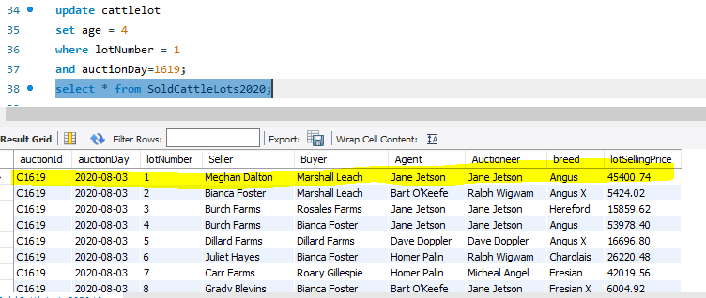

## View #2

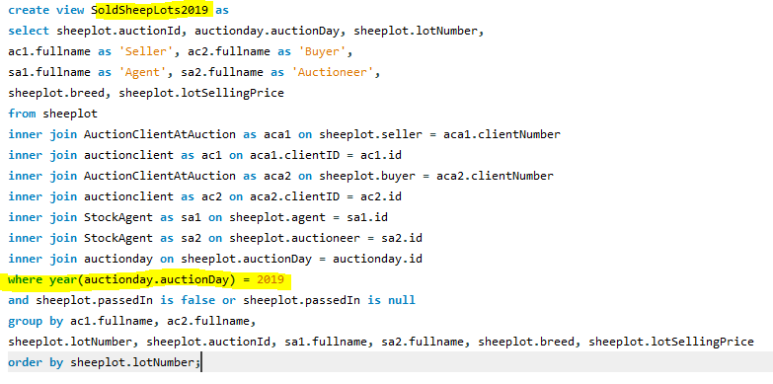There were no sheep auctions in 2020, so instead I am using the 2019 auction:

Tests:

Before:

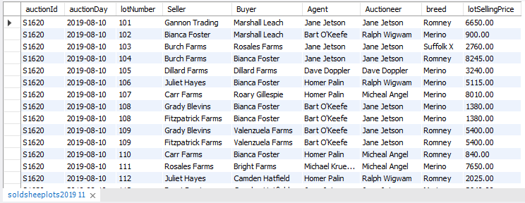

After:

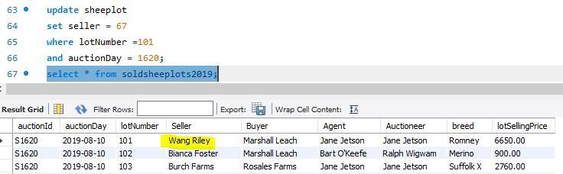

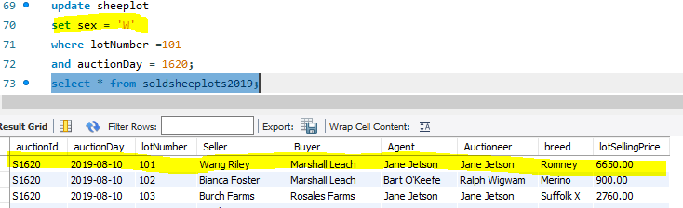

# Triggers

## Trigger #1

This trigger is sort of made up of 5 triggers:

* one trigger is for CattleLot, which updates totalBought and totalSold fields for cattle lots
* one for SheepLot with the same functionality
* two for delete on cattlelot and sheeplot to update the fields again in case the data entries are deleted (could be a typo or something, I do not know, but this way all the use cases are covered and the data is always accurate)
* and one for whenever there is an update in AuctionClientAtAuction, it copies the totals into the AuctionClient table.

The code is too long to take a screenshot of.

Tests:

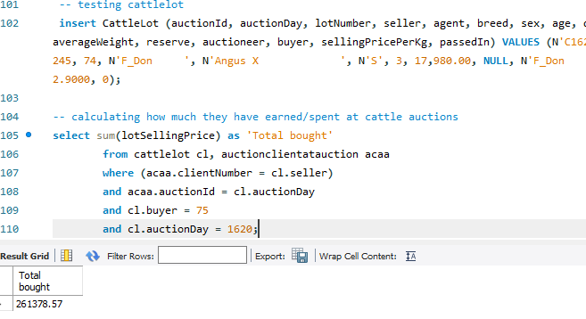After insert on cattlelot:

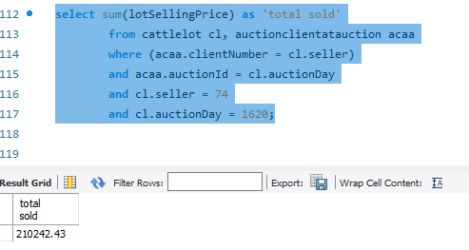

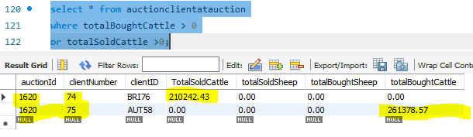

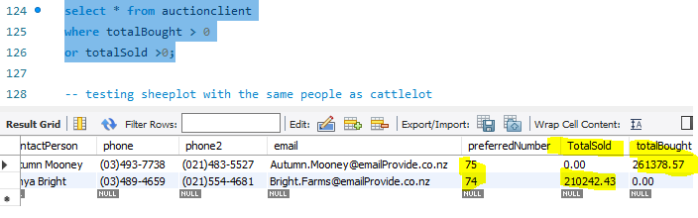

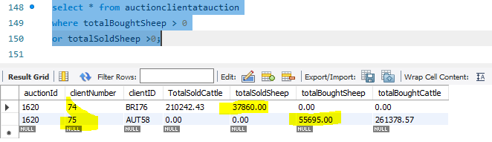When adding a sheeplot with the same people:

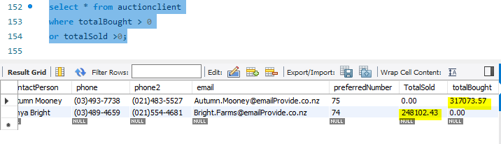

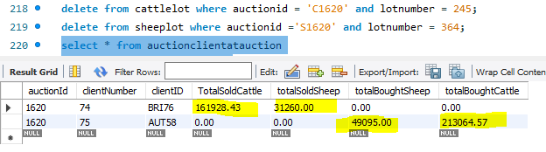Testing for the deletion of cattle/sheep lots:

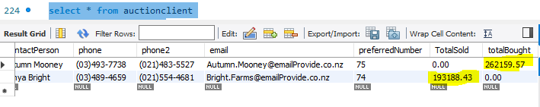

## Trigger #2

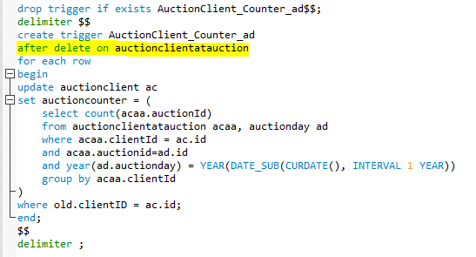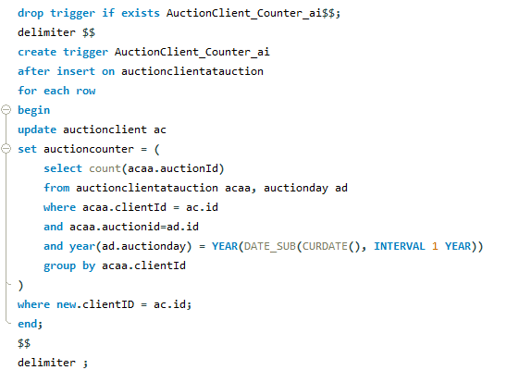

Tests:

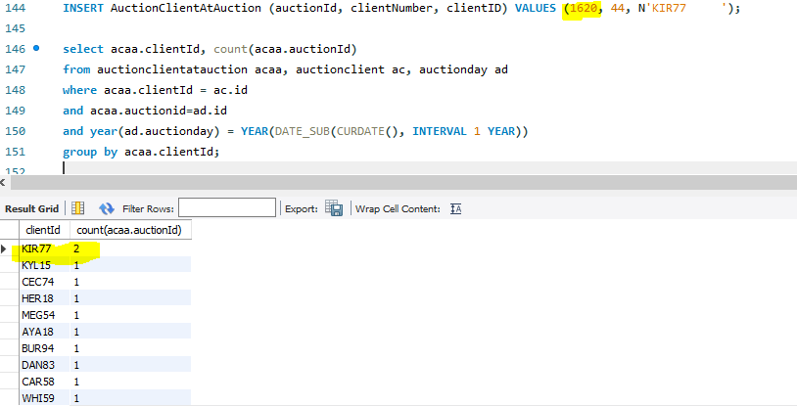The first testing query checks how many times a client is registered in an auction in AuctionCLientAtAuction table in the last year:

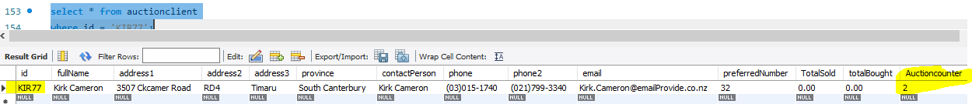This query checks the AuctionClient table:

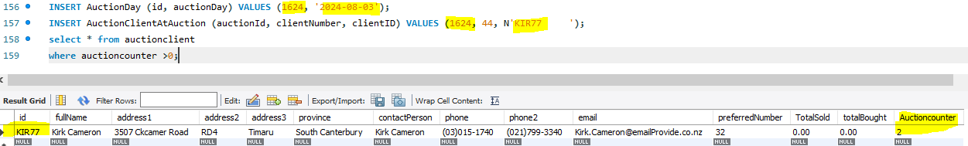

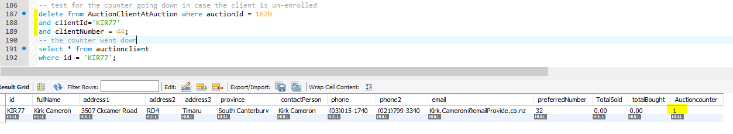Checking for when the entry is deleted (the client is un-enrolled or something like that):

# Stored procedures

## SP #1

Tests:

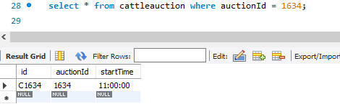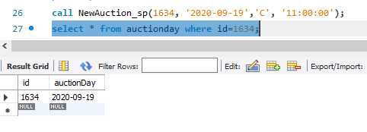

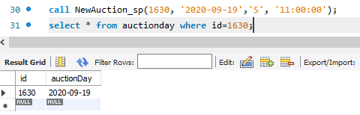

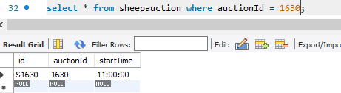

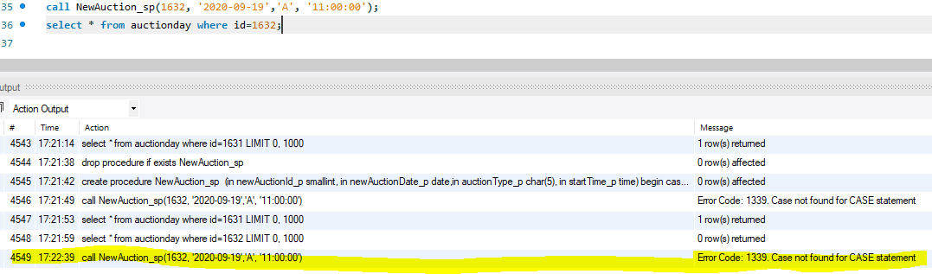If the type of the auction is wrong and not ‘C’ or ‘S’, it will not add a new row in AuctionDay, preventing from the error with duplicate keys when adding it again after fixing the typo:

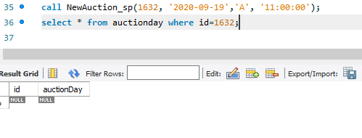

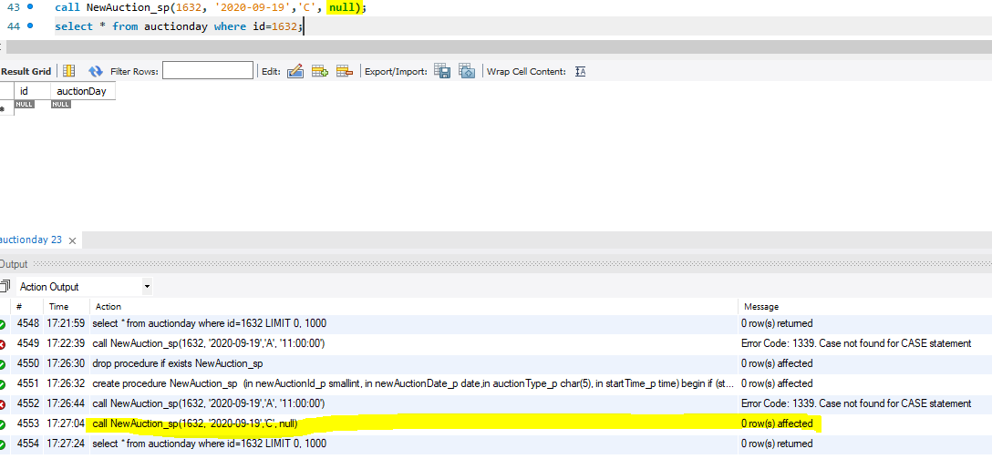If one of the fields is null, then it will not add anything:

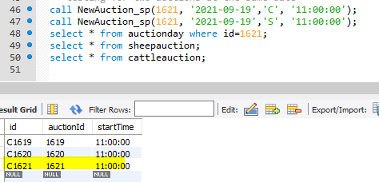Testing for two different auctions (cattle and sheep) taking place on the same date and under the same id:

## SP #2

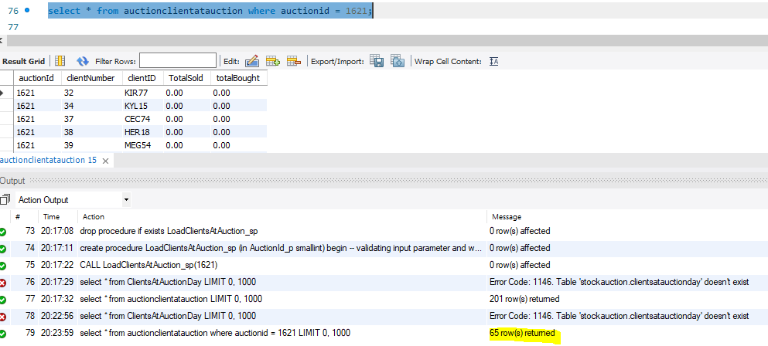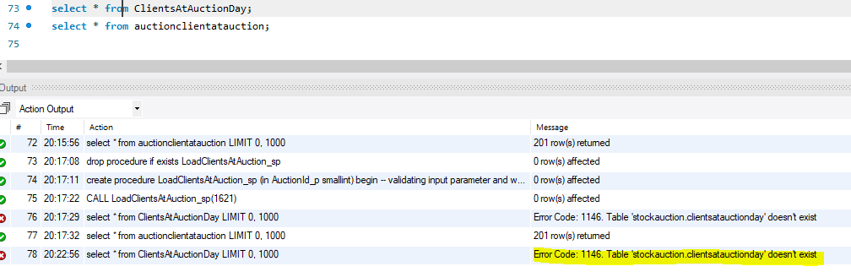After using the LoadClientsAtAuctionScript:

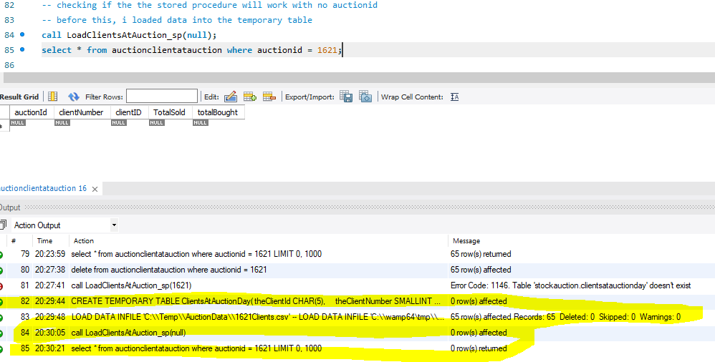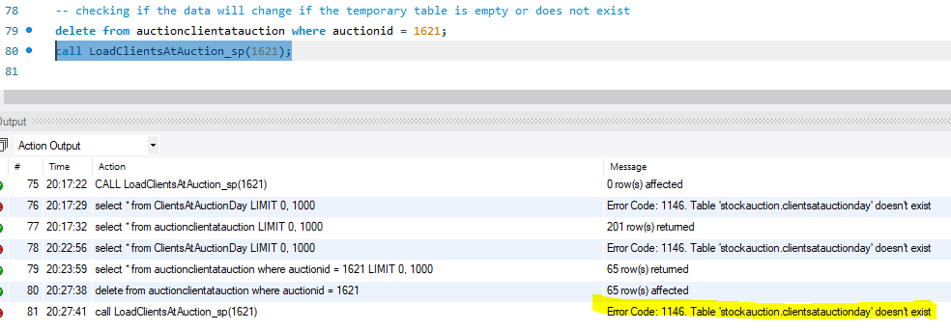

## SP #3

For this stored procedure I had to change the type of quantity in sheeplot to unsigned tinyint because there was a lot with a 128 value (but for signed tinyint the max value is 127) inside the stored procedure.

Tests:

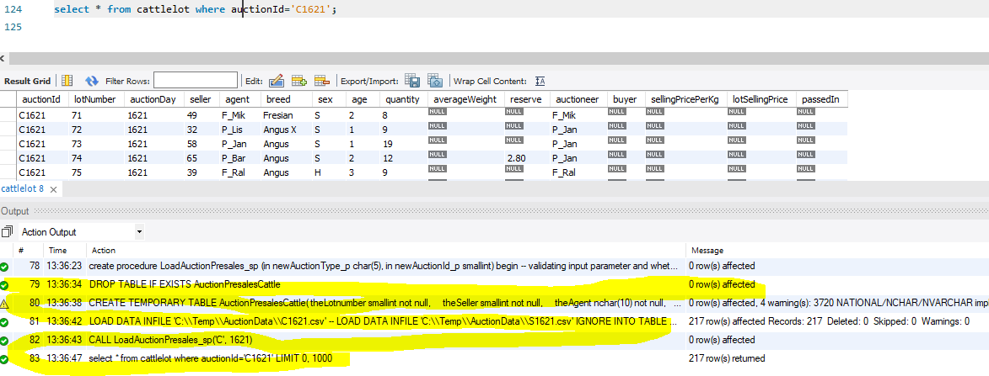Cattlelot:

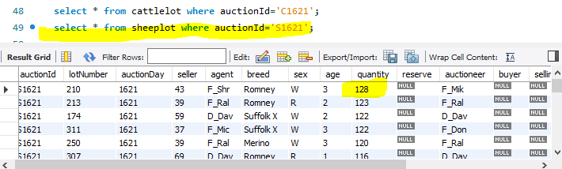SheepLot:

## SP #4

(The script is too long to take a screenshot of)

Tests:

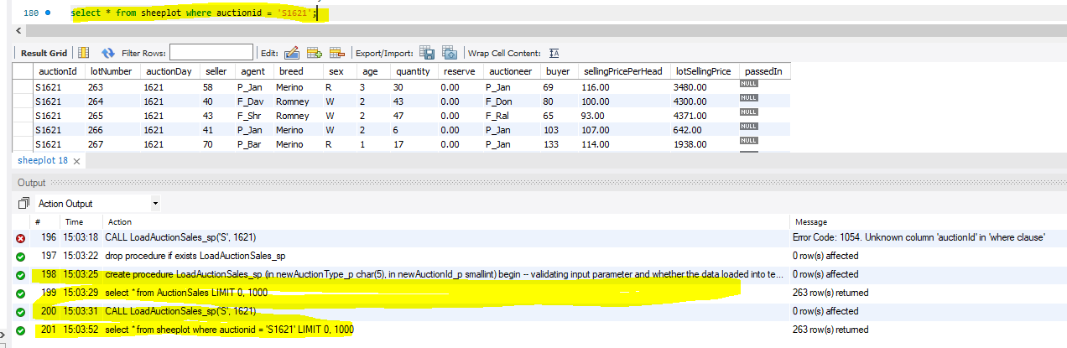Sheeplots:

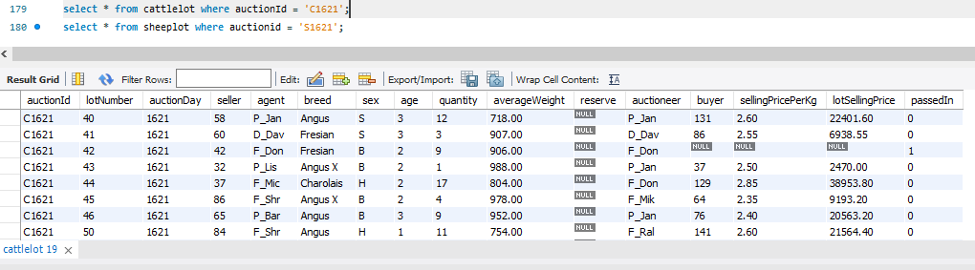Cattlelots:

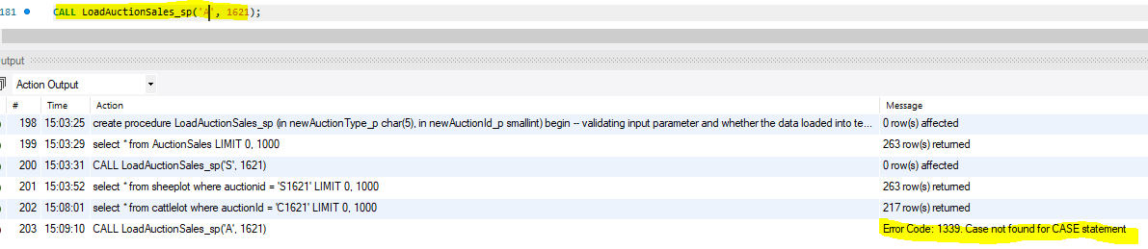

## SP #5

(The script is too long to take a screenshot of)

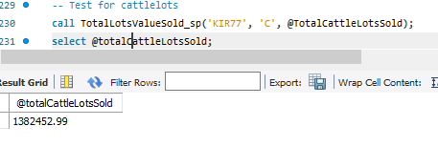Tests: total values may differ because my database has been populated with more data from testing other procedures.

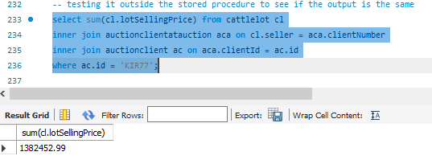

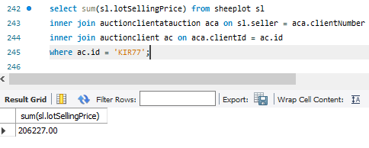

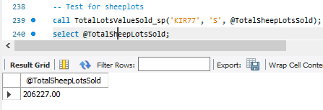

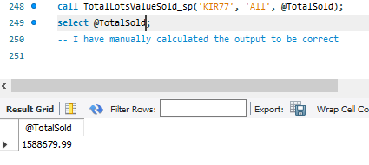

## SP #6

Tests:

